**2017**

1. A brass ball is hanging from a stiff cotton thread. Draw a neat labelled diagram showing the forces acting on the brass ball and cotton thread [2 marks]
2. The distance between two bodies is doubled. How is the magnitude of gravitational force between them affected [2 marks]
3. Why is the jack screw provided with a long arm? [2 marks]
4. A uniform half meter rule balances horizontally on a knife edge at 29 cm mark when a weight of 20 gf is suspended from one end
   1. Draw a diagram of the arrangement
   2. What is the weight of the half meter rule [3 marks]

**2016**

1. Give an example of a non-contact force which is always of attractive nature. How does the magnitude of this non-contact force on the two bodies depend on the distance of separation between them [2 marks]
2. A stone of mass ‘m’ is rotated in a circular path with a uniform speed by tying a strong string with the help of your hand. Answer the following questions
   1. Is the stone moving with a uniform or variable speed
   2. Is the stone moving with a uniform acceleration? In which direction does the acceleration act?
   3. What kind of force acts on the hand and state its direction? [3 marks]

**2015**

1. When a body is placed on a table top, it exerts a force equal to its weight downwards on the table top but it does not move or fall
   1. Name the force exerted by the table top
   2. What is the direction of the force [2 marks]
2. On what factors does the position of centre of gravity of a body depend? [1 marks]
3. What is the SI unit of the moment of force [1 mark]
4. Name the factors affecting the turning effect of a body [2 marks]
5. (a)Define equilibrium [1 mark]

(b)In a beam balance when the beam is balanced in a horizontal position, it is in ________ equilibrium [1 mark]

1. Explain the motion of a planet around the sun in a circular path [2 marks]
2. A nut is opened by a wrench of length 20 cm. if the least force required is 2 N, find the moment of force needed to loosen the nut [2 marks]

**2014**

1. A force is applied on (i) a non-rigid body and (ii) a rigid body. How does the effect of the differ in the above two cases [2 marks]
2. A metallic ball is hanging by a string from a fixed support, Draw a neat labelled diagram showing the forces acting on the ball and the string [2 marks]
3. What is the weight of the body placed at the centre of the earth [1 mark]
4. Is it possible to have an accelerated motion with a constant speed? Explain [2 marks]
5. Two forces each of 5N act vertically upwards and downwards respectively on the two ends of a uniform meter rule which is placed at its mid-point as shown in the diagram. Determine the magnitude of the resultant moment of these forces about the mid-point [4 marks]

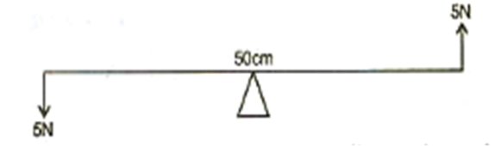

**2013**

1. Give any two effects of a force on a non-rigid body [2 marks]
2. One end of a spring is kept fixed while the other end is stretched by a force as shown in the diagram.

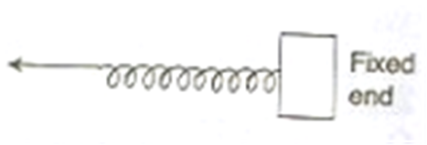

* 1. Copy the diagram and mark on it the direction of the restoring force
  2. Name the instrument which works on the above principle [ 2marks]

1. Where is the centre of gravity of a uniform ring situated [1 mark]
2. “The position of the centre of gravity of a body remains unchanged even when the body is deformed” state whether the statement is true or false [1 mark]
3. With reference to their direction of action, how does a centripetal force differ from a centrifugal force? [1 mark]

**2012**

1. Define 1 kgf. How is it related to the S.I. unit of force [2 marks]
2. What are non-contact forces [1 mark]
3. How does the distance of separation between two bodies affect the magnitude of the non-contact force between them [1 mark]
4. A boy of mass 30 kg is sitting at a distance of 2m from the middle of a see-saw. Where should a boy of mass 40kg sit so as to balance the see-saw? [2 marks]
5. (i) What is meant by the term ‘moment of force’.

(ii) If the moment of force is assigned a negative sign then will the turning tendency of the force be clockwise or anticlockwise [2 marks]

1. (i) Which of the following remains constant in uniform circular motion: speed or velocity or both?

(ii) Name the force required for uniform circular motion. State its direction [3 marks]

**2011**

1. (i) Define one newton

(ii) Write the relation between S.I. unit and C.G.S. unit of force [2 marks]

1. Where does the position of center of gravity lie for
   1. A circular lamina
   2. A triangular lamina [2 marks]
2. A man can open a nut by applying a force of 150 N by using a lever handle of length 0.4 m. what should be the length of the handle if he is able to open it by applying a force of 60 N? [2 marks]
3. A uniform meter scale can be balanced at the 70 cm mark when a mass of 0.05 kg is hung from the 94 cm mark
   1. Draw a diagram of the arrangement
   2. Find the mass of the metre scale [4 marks]

2008

1. A body of mass 1.5 kg is dropped from the second floor of a building which is at a height of 12 m. what is the force acting on it during its fall? [g=9.8 m/s2] [2 marks]

2006

1. A uniform meter scale is kept in equilibrium when supported at the 60 cm mark and a mass M is suspended from the 90 cm mark as shown in the figure. State with reasons whether the weight of the scale is greater than or less than or equal to the weight of mass M [2 marks]
2. Mention any two differences between the mass and the weight of a body [2 marks]

2003

1. The weights of two bodies are 2 N and 2 kgf respectively. What is the mass of each body (take g=10 m/s2) [2 marks]

2001

1. What is the weight of mass 12 kg. what is the force acting on it [2 marks]